WHAT IS HEBRAIC CHURCH?

It might be best to begin this essay by explaining what Hebraic Church is not! It is not a new denomination or a new gospel! It is notable that many believers today are finding that they are seeking more of Jesus in their every-day Walk of Faith, but are not always receiving either the teaching or deeper fellowship in their own “church” settings which they sense is vitally important. In many churches and for many believers, bluntly (and prosaically) the institutional church is simply not “scratching where it itches”. This deficiency includes many of the traditional teaching conferences, which today seem to be coalescing around either:

- a touchy-feely religion where the only constant is that “God loves you”, backed with happy clappy “worship”
- an ever-narrower “theology” where like-minded souls agree with each other end reinforce doctrinal shibboleths
- a worldly agenda – where the church is ever-more closely identifying with the World outside and adopting its mores

And for some (and perhaps for a steadily increasing number) there is the inevitable big question-mark as to precisely what the institutional church (sometimes their church!) actually stands for. We are all aware that the institutional church, in parts, is simply adopting the World’s agenda and the World’s language – in sharp contradistinction to the Scriptures or to the received truth of the historic church.

Hebraic Church is undoubtedly a part of God’s current provision to shore-up the leaking walls of the church’s teaching and provide a more biblically astute alternative to the World’s agenda. But it is much more than that. It also wants increasingly to devise a distinctive and biblically faithful presentation of the good news of Jesus – to a generation that scarcely knows Him. Hebraic Church wants to reach out to those “fields that are white unto harvest” (John 4:35) – all those people who would potentially respond, if only a simple message was presented to them.

But …… why “Hebraic” and why “Church”? Let’s explore these two ideas:

Hebraic

The institutional church was “infected” by Greek philosophy from the earliest times. It seems that even Paul, the apostle, attempted to use philosophical concepts in his presentation of the gospel in the Areopagus (Acts 17: 22-31). His immediate refocus around the cross expressed so forcefully in 1 Corinthians 1: 18 to 2:5 may be a response to his experience of failure in Athens. Note there is no letter to a young Athenian Church! It is assumed that Paul’s overtures to the Athenians failed – the gospel was rejected.

Greek philosophical norms were incorporated into the Christian Church from the time that Constantine “nationalized” the church after he had a religious experience. I hope that readers will forgive what must be a considerable over-simplification of the events, but no doubt most readers will have a sense of what we are driving at here. The “church” became an organ of the State - and the rest, as they say, is history!

Whilst there is nothing intrinsically bad about a Greek mindset, it never the less colours the way we approach the Scriptures. Most people are simply unaware of this mindset – and equally they forget that Jesus was a Hebrew living in a Hebrew society, and (arguably) used a primarily Hebrew mind as He preached the good news of the Kingdom. Now we are not trying to “tie-down” the Lord Jesus into any particular mindset – plainly He rises above any such limitation. But we do not! We remain blissfully unaware for the most part, that Greek culture, Greek philosophy, and a Greek mindset dominate our Western World (and arguably dominates, today, even in the Indian sub-continent and Asiatic world). When we become aware of this mindset, and make due allowance for it, then we can encounter Jesus in a different way, a fresher way, and an altogether more exciting way!

We forget too easily that Jesus is the Jewish Messiah and the Saviour of the whole world. We forget that God has ongoing purposes, and indeed end-time purposes, for Israel. Hebraic Church is an endeavour to build-in to our Christian life an understanding of these (sometimes controversial) truths. Hebraic Church specifically repudiates:

Repalcement Theology - the idea that the church replaces Israel in God’s affections, or even, in extremis, that the church is Israel - lock stock and barrel! (This theological construct is sometimes convoluted with the equally erroneous Fulfillment Theology, but in practice the two seem to be pretty much identical – it is just that the second is more polite than the first!)

Two Covenant Theology – the idea that Jews are “saved” by being good observant Jews (and keeping the Mosaic Law) and that Christians are “saved” simply by believing in Jesus

On the basis that entire research theses and numerous books have been written on these two subjects, this essay is not the place to resolve them, but it is important that those who see themselves as part of the Hebraic Church initiative, are clear about where we stand. Replacement Theology and Two-Covenant Theology are unscriptural, defy the clear teachings of Jesus and the progressive revelation of Scripture and specifically ignore the key teaching of Apostle Paul in Romans chapters 9 thru 11. By the same token “Judaising” the church, or any desire to seek peace through Torah observance is equally to be rejected (see Galatians chapter 5). So where do (most) in the Hebraic Church initiative actually stand on these issues? I would suggest that where most “Hebraics” stand is clearly set out in the diagram below, which sees Hebraic understanding as a sort of continuum – and inevitably different people are in different places on that continuum. To the left of the diagram lies, definitively, Replacement Theology. To the right lies ever-bolder Judaising. Plainly most Hebraics seek a clear, identifiable, position between these two extremes.

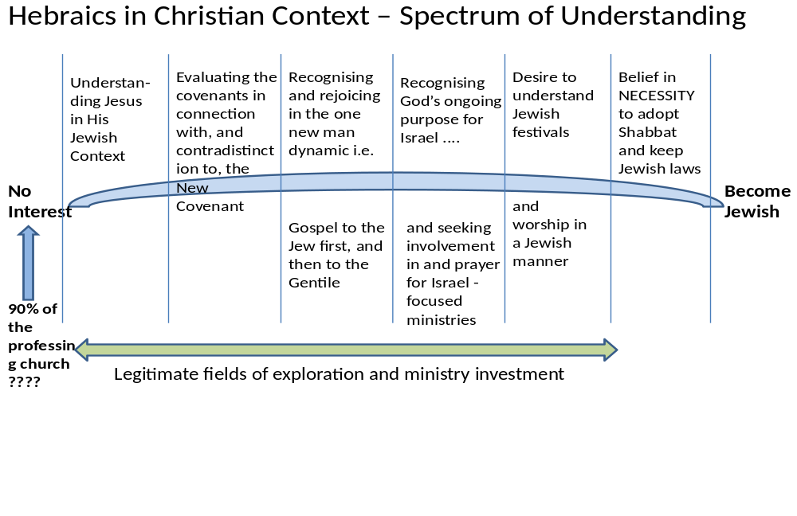

Incidentally, we adopt the generic term Enlargement Theology as espoused by, for example the Rev Alex Jacob (interestingly, today the CEO of CMJ (the Church’s Ministry to Jewish People)), as a biblically astute course between the two extremes of RT on the left, and 2CTh and/or Judaizing, on the right. Again this short essay is simply not the place to resolve these deep issues, but hopefully we have positioned ourselves clearly on that scale which we have called “legitimate fields”. Most Hebraics would recognize Enlargement Theology as a biblically faithful description of where they stand, albeit there are a range of legitimate positions within and under that general heading, as the diagram indicates.

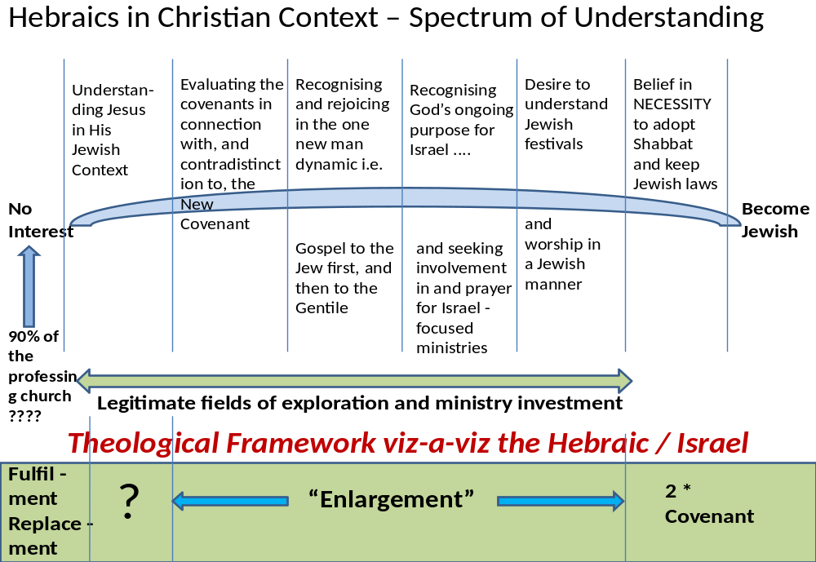

In summary, then, “Hebraic” indicates that we recognize that the Hebraic dynamic of the Christian faith (some call this Jewish Roots, but that term is, today, also a very confusing and diffuse spectrum, and most Hebraics are VERY cautious in using the term for that very reason).

Church

In using the term “church” we are simply reflecting the Greek (!) biblical term ekklesia – those called out to follow Jesus as Lord and as Saviour. Those of us who seek to explore the Hebraic dynamic also recognize a calling to understand Jesus the Jewish Messiah and to rejoice in that wonderful truth. Most of us as individuals have a clear sense of calling into this wonderful area.

Hebraic.Church

It is almost inevitable today that any ‘movement’ will have some sort of a WWW presence and use the WWW as a mechanism to network and share ideas. Hebraic Church is, then, a loose network of Christian believers, as well as people presently with no religious persuasion, to explore the Jewish Jesus and God’s current priorities as best we can discern them, through the guidance of the Holy Spirit. Readers might want to search out e.g. Steve Maltz’s book “Hebraic Church” which fleshes out many of the issues and opportunities. Also, 20-20 Vision is a helpful one page summary of what Hebraics sense are God’s clear priorities for His ekklesia at this time. It will be noted that only two of the seven priorities identified are specifically Hebraic in context! Hebraic Church, as an initiative, is not a “one trick pony”. We do recognize a broader set of priorities and issues with which we Hebraics must also engage and provide an element of thought-leadership.

Who runs Hebraic Church?

Hebraic church is not an institution, so much as a dynamic within God’s ongoing purposes. It is definitely of today, and we sense it will go on being important to God’s current purposes perhaps for the next generation. In principle, however, it is the entire community of Hebraics who “run” the enterprise. Hebraic.Church is emphatically egalitarian! We are not seeking to become a structure. We are not seeking to be definitive about what people should, and should not “believe” except within the clear opening statements above - that Hebraics are unanimous in their rejection of Replacement Theology, no matter how that mindset manifests itself, as well as the hyper-Liberal Two Covenant Theology.

It is likely that some ‘leading lights’ will emerge from time to time, but as there is no formal structure to Hebraic Church (rather a simple resourcing for those on a similar journey) so the body of Hebraic Church will grow and mature - it is after all a dynamic, and all Christians should consider themselves as being on a journey of faith.

It is possible, if not likely, that some “wacky” individuals and groups may adopt the title “Hebraic Church” so as to muddy the waters. This is sad, but not overly alarming. That so much of broader secular society and the institutional church is “against” Israel and seek to sever the church from its Hebraic root (Romans 12: 18) is a given. However, it is this very antipathy that may preserve Hebraic Church as a concept from too much impersonation! It is more likely that the stance of Hebraic Church will be misrepresented as a “Judaizing” influence, which in reality it is not. We are very mindful of the teaching in Galatians.

One New Man?

So what is the relationship between a Jew who chooses to follow Jesus a non-Jew. Is there a different path to salvation? Absolutely not! Although the starting points of their journey to faith might be subtly different, their needs are identical, as this diagram illustrates. Once again, we must observe that this short essay is not the place to permanently resolve this issue to the satisfaction of all. But the diagram below should, at least, indicate where Hebraics stand on this important question. Incidentally, the phrase one new man comes directly from Ephesians 2: 14.

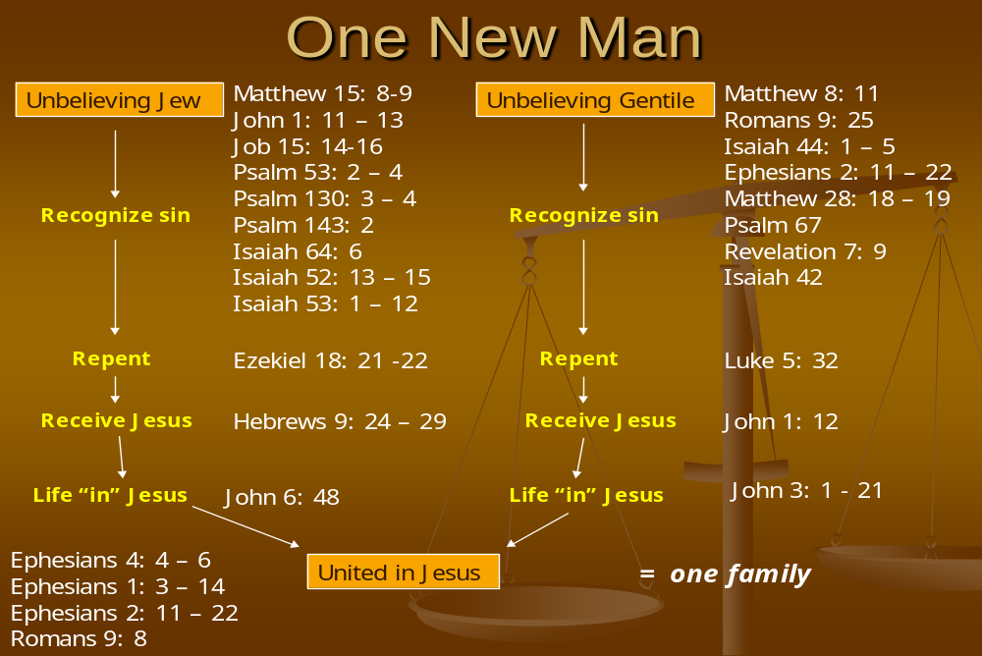.

Welcome!

If you sense that God is doing something fresh and good in our day, it may be that Hebraic.Church is for you. Why not check us out on www. ******/******. We want to be a safe place where both Jew and Gentile can encounter the risen Lord Jesus, as well as explore Him as Yeshua the Jewish Messiah and Jesus the Saviour of all Mankind.

Peter Sammons © 2016

